SSN College of Engineering, Kalavakkam
Department of Computer Science and Engineering
III Semester - CSE

UCS 1312 Data Structures Lab Laboratory

Academic Year: 2021-2022 | Batch: 2020-2024
Date of Assignment: 10.12.2021

Exercise 13: Implementation of Shortest Path Finding algorithm
[CO2, K3]

The cityADT contains the number of cities and the connectivity information between the cities (adjacency matrix). Write the following methods.

- void create(cityADT *C) – will represent the graph using adjacency matrix
- void disp(cityADT *C) – Display the graph
- void Floyd-Warshall(cityADT *C)
– displays the initial, intermediate and final distance & predecessor tables
- char * displayPath(cityADT *C, source, destination)
– Find the path of the intermediate cities between the
source and destination cities along with the cost

Note:

- Implement cityADT with the specified operations in cityADTImpl.h
- Write a menu driven application to utilize the cityADT.

Demonstrate ADT with the following test case

Input:
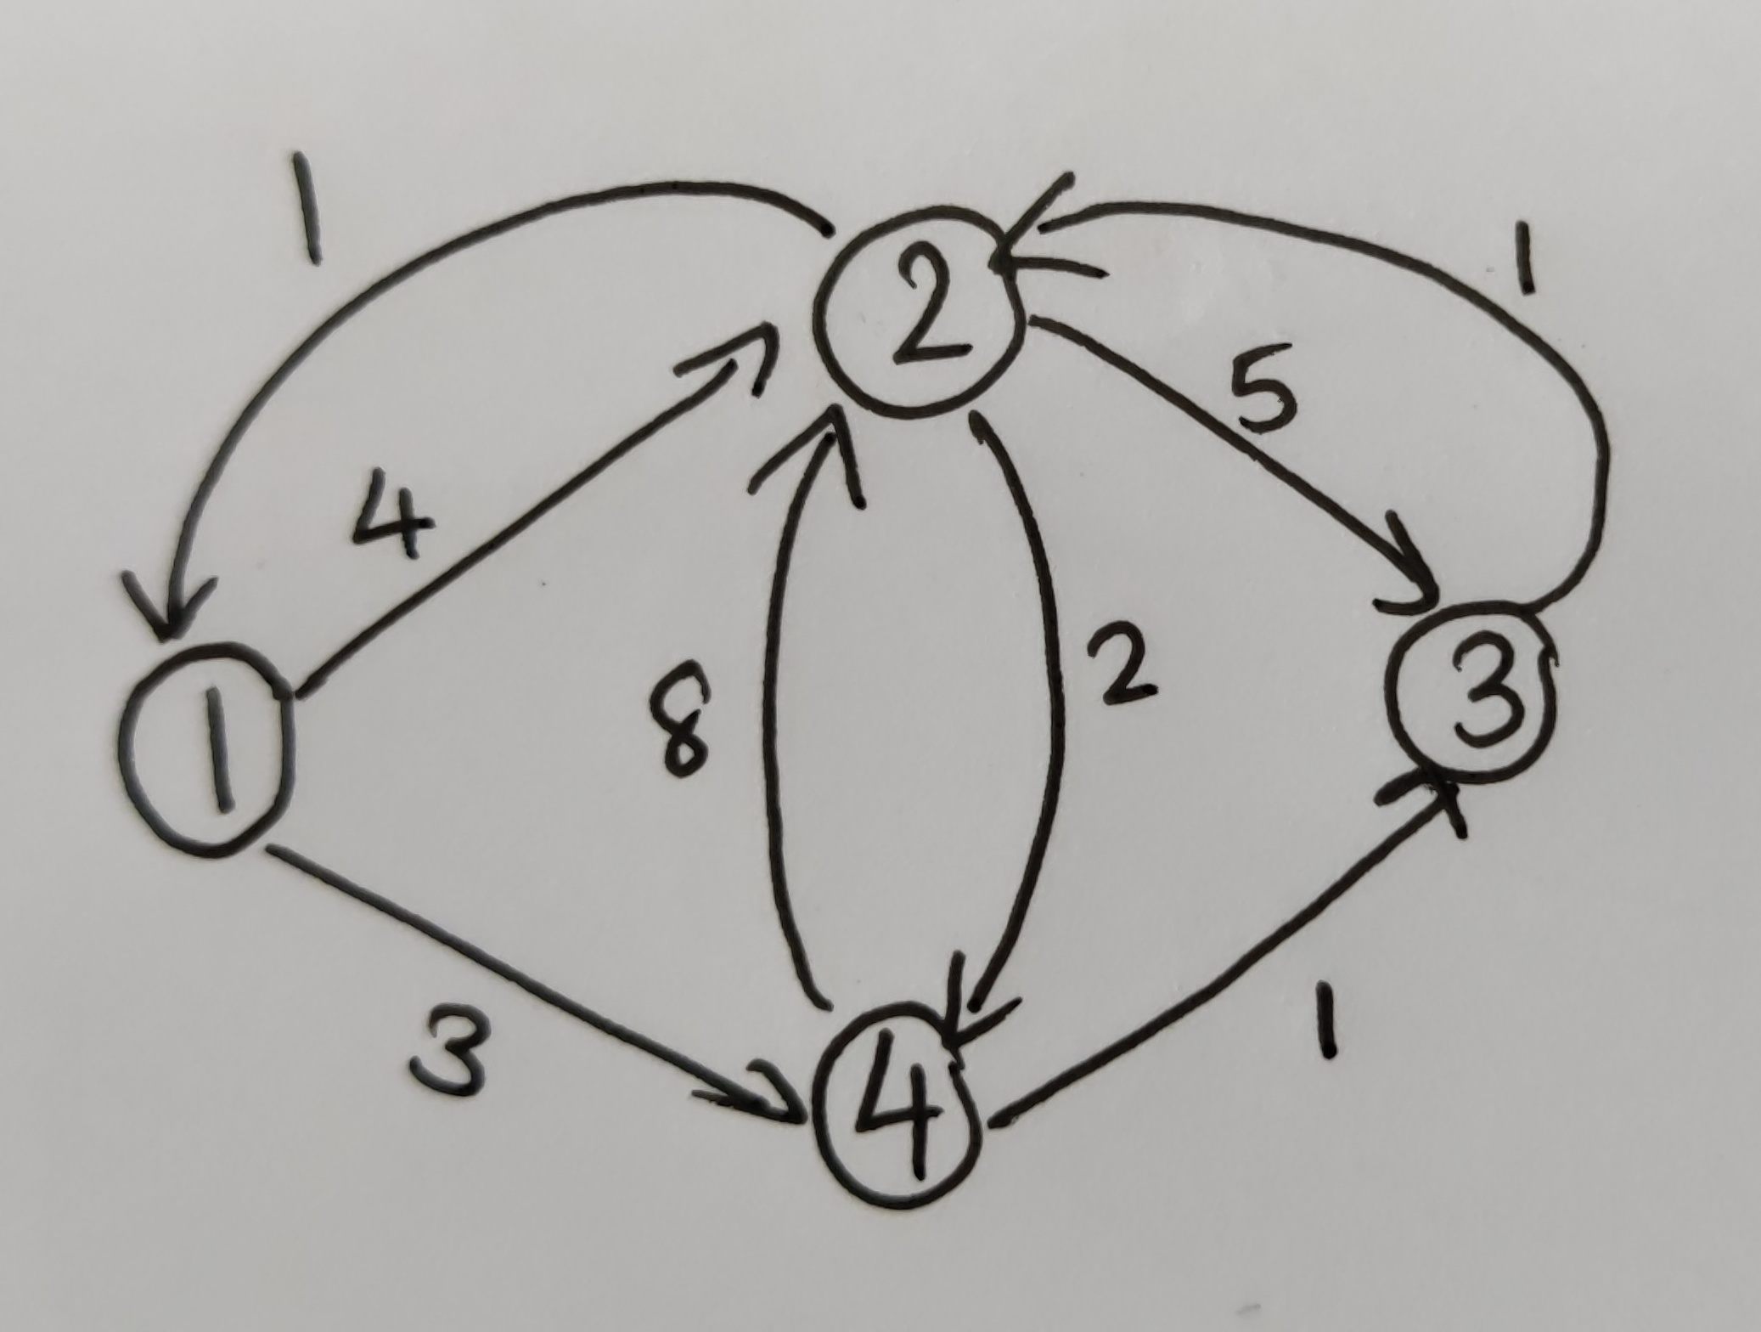

Output:
Predecessor and Distance Matrices
